Name: أحمد عادل على محمد على كريمة
B.N/88

Topic: Programming Language

Application Brief:
A programming language is a formal language comprising a set of strings that produce various kinds of machine code output. Programming languages are one kind of computer language, and are used in computer programming to implement algorithms.

Screenshots:
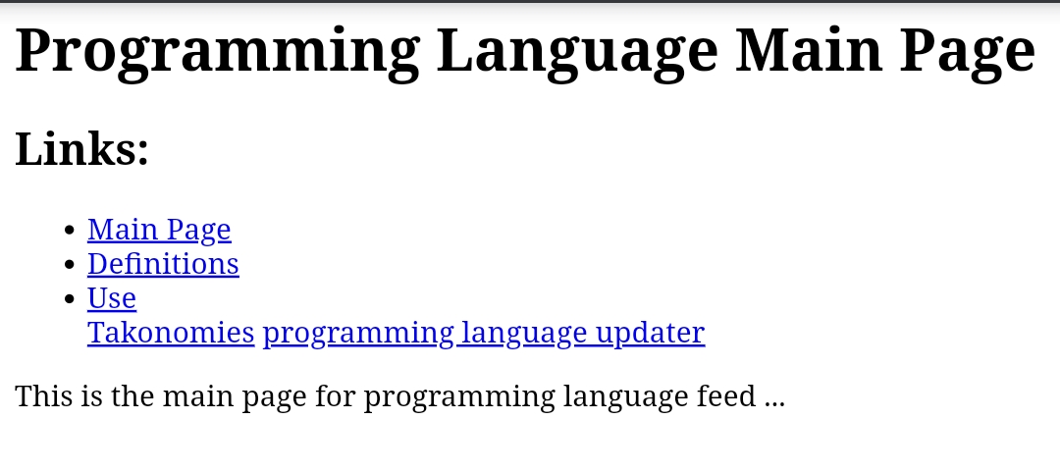
Source code:
